GTM Prior Consent Setup Instructions

Step 1: Create the prior consent trigger

1. Open tag manager workspace
2. Navigate to Triggers configuration

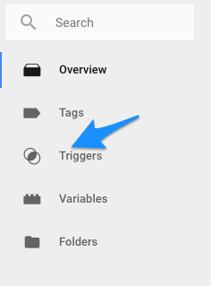

3. Click "New" button to create a new trigger.
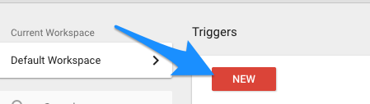

4. Select the "Custom Event" trigger type
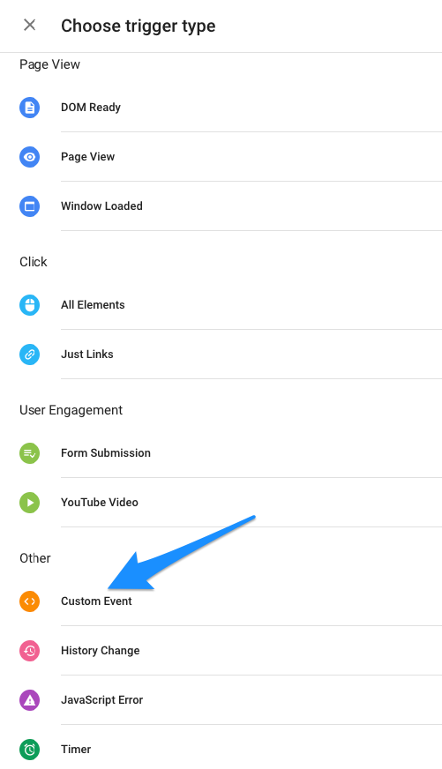

5. Modify the name so you can identify the trigger more easily. We suggest Prior Consent Trigger, but it is up to you
6. Set the Event Name to "evidonConsentGiven" (without the quotes)
7. Set the trigger to fire on All Custom Events

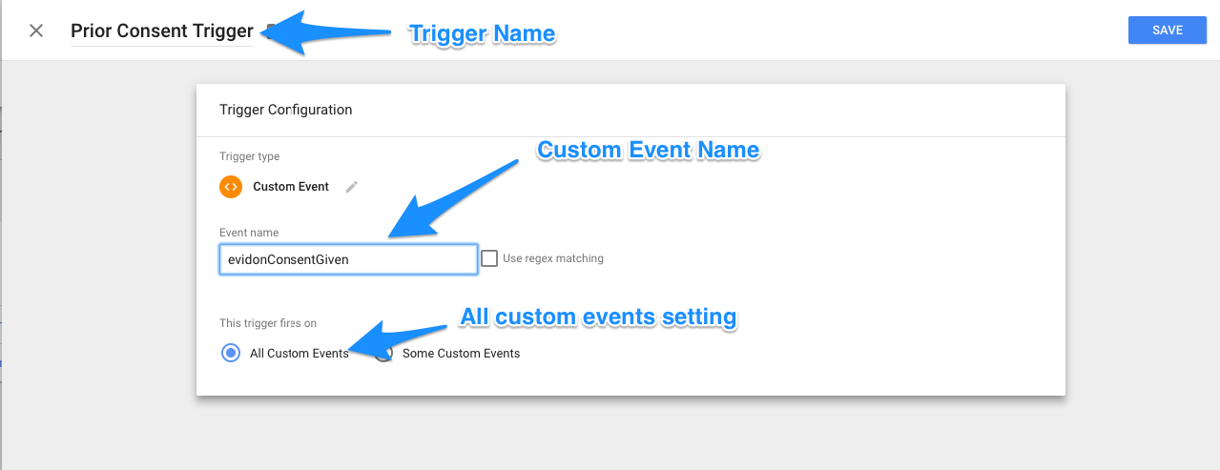

8. Save the new consent trigger

Step 2: Modify all tags requiring prior consent to use the new trigger

1. Identify all tags/scripts which need to wait for user consent before they execute.
2. Open the tag list

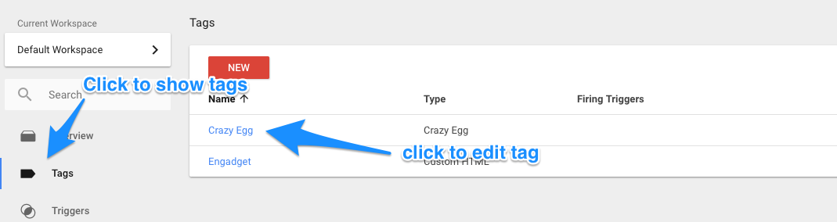

2. Click each script to set the trigger
3. In the "Triggering" section highlight to bring up the Edit pencil
4. Click the pencil to edit
5. Remove any trigger which would cause the tag to fire before consent is given
6. Click the add button (+)
7. Choose the new Prior Consent Trigger from the trigger list

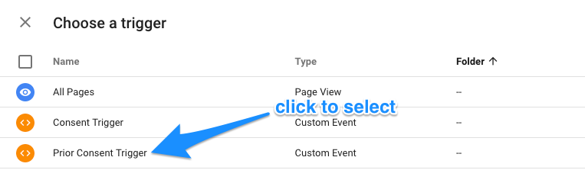

8. Save your changes

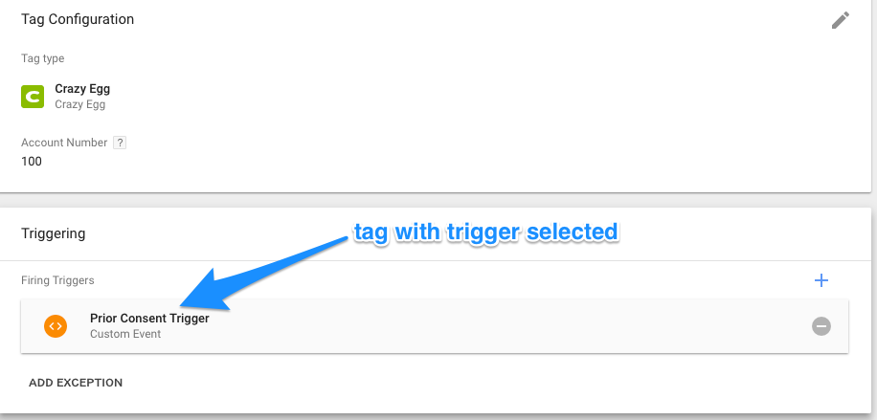

Step 3: Publish Tag

After you have made all the necessary changes publish your new tag manager settings so they are live.

